CodeAlpha
ASSIGNED TASK 1:
Basic Network Sniffer

Submitted By:
Syed Wajih Ul Hassan Naqvi
ID: CA/DF1/92245

Table of Contents
- Introduction
- Objectives
- Tools & Technologies
- Working Principle
- Source Code Overview
- Sample Output
- Challenges Faced
- Advantages & Limitations
- Conclusion
- References

1. Introduction
A network sniffer is a tool that captures packets travelling across a network. It is commonly used by network administrators and cybersecurity professionals to troubleshoot connectivity issues, monitor traffic, and understand communication between devices. This project demonstrates the basic principles of packet capture using Python and the Scapy library.

2. Objectives
• Capture live network packets.
• Display source and destination IP addresses.
• Identify protocols such as TCP, UDP, and ICMP.
• Display packet summaries and payload information.

3. Tools & Technologies
Programming Language: Python
Library: Scapy
IDE: Visual Studio Code
Operating System: Windows 10/11
Additional Software: Npcap

4. Working Principle
The program listens on the selected network interface and captures packets in real time. For each packet, it checks whether it contains an IP layer. If so, it extracts the source IP, destination IP, protocol, and other useful information. TCP and UDP port numbers are displayed when available, followed by a packet summary and payload.

5. Source Code Overview
The application uses the sniff() function from Scapy to continuously capture packets. A callback function processes each packet and prints the extracted details. The program continues running until the user presses Ctrl+C.

6. Sample Output
CODE:
from scapy.all import sniff
from scapy.layers.inet import IP, TCP, UDP, ICMP

print("="*60)
print(" BASIC NETWORK SNIFFER")
print("="*60)
print("Capturing packets... Press Ctrl+C to stop.\n")

def process_packet(packet):

if packet.haslayer(IP):

print("-"*60)

print(f"Source IP : {packet[IP].src}")
print(f"Destination IP : {packet[IP].dst}")

if packet.haslayer(TCP):
print("Protocol : TCP")
print(f"Source Port : {packet[TCP].sport}")
print(f"Destination Port: {packet[TCP].dport}")

elif packet.haslayer(UDP):
print("Protocol : UDP")
print(f"Source Port : {packet[UDP].sport}")
print(f"Destination Port: {packet[UDP].dport}")

elif packet.haslayer(ICMP):
print("Protocol : ICMP")

else:
print("Protocol : Other")

print("\nPacket Summary:")
print(packet.summary())

print("\nPayload:")
print(packet.payload)

sniff(prn=process_packet, store=False)
OUTPUT:
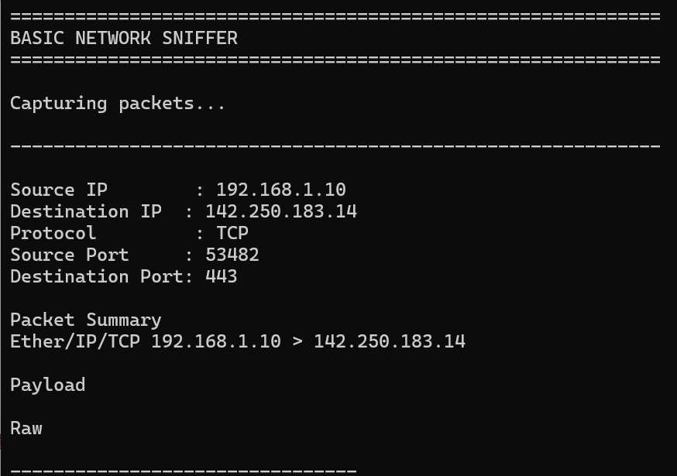

7. Challenges Faced
Installing Scapy and Npcap, running the program with administrator privileges, and understanding protocol layers were the main challenges encountered during development.

8. Advantages & Limitations
Advantages:
• Easy to understand.
• Useful for learning packet analysis.
• Lightweight implementation.
Limitations:
• Does not decrypt encrypted traffic.
• Requires administrator privileges.
• Intended for educational and authorized use only.

9. Conclusion
This project successfully demonstrates the fundamentals of network packet capture and analysis. It provides practical exposure to networking concepts and highlights how cybersecurity professionals inspect network traffic for troubleshooting and security monitoring.

10. References
1. Python Documentation
2. Scapy Documentation
3. RFC 791 (Internet Protocol)
4. RFC 793 (Transmission Control Protocol)

